BASICS OF DRAWING
Arts Bridge Lesson 2
Thursday, September 19

Objective: Students will learn and practice basic drawing skills.

Total Lesson Time: 45 minutes

Goals:
- Learn to fill the whole page/space
- Learn different techniques of drawing: lines, hatching, cross-hatching, circles, shading

Materials:
- Pencils
- Three 4x6 half-sized sheets of paper per students
- Shading practice sheet

Plan:

Warm-Up (10 min):
Provide students with one half-sheet of paper. Give the following drawing prompts. Instruct that they have to fill the whole page.
- What would happen if it rained chocolate milk?
- What does your favorite ocean animal look like?
- What if someone visited you from outer space?

Skills Practice (35 min):
Fold another sheet of paper into quarters.
Introduce and teach these skills in each quarter of the paper. Demonstrate from the overhead and have students practice on their own papers.

Circles - Top Left Square (3 min)
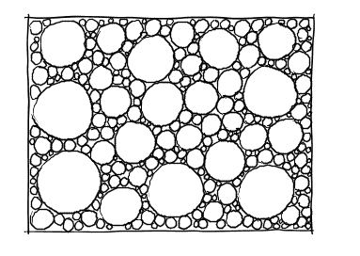
Start with 5-6 bigger circles, then begin to fill the space with several medium-sized circles, lots of small circles, then fill the remainder of the space with tiny circles.

Hatching - Top Right Square (3 min)
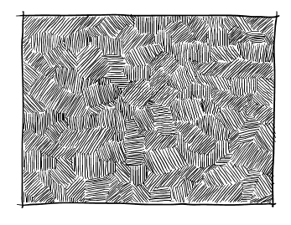
Short parallel lines in patches. Can go in all different directions. Fill the whole space.

Cross-hatching - Bottom Left Square (3 min)
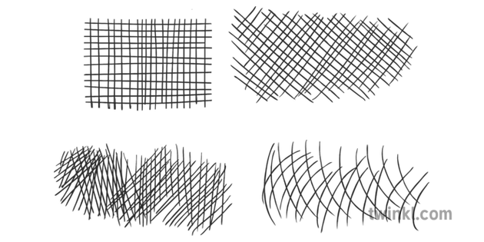
Lines that cross each other. Can be straight, diagonal, mixed directions or bent.

Draw the way a tree grows - Bottom Right Square (3 min)

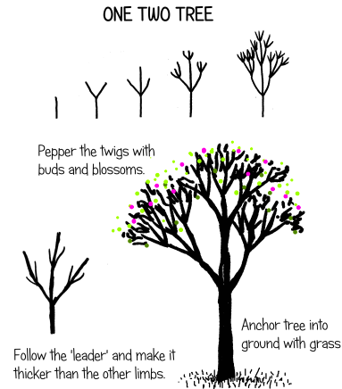
Start at the bottom of the paper, draw a straight line up. Add twigs. Thicken lines. Add buds / blossoms.

Shading (8 min):
Provide students with shading practice sheet. Help them see you can shade using the different techniques we just practiced.
Darker = more pressure
Lighter = less pressure
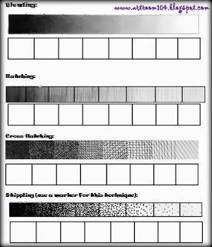

3 Lines Create a Story (15 minutes)
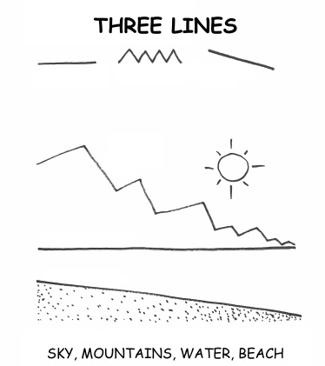
On the 3rd sheet of paper, draw lines from one edge of the paper to the other. Using one of the different drawing techniques that we learned, practice shading the beach, water, sky, and mountains. Encourage them to add trees if they want. Add themselves somewhere to the picture - are they on the beach? Swimming in the water? Climbing the mountain?
If students finish early with their three line story, have them go back to the warm-up prompt. What can you add to it from what we learned today? What type of shading can you incorporate?

